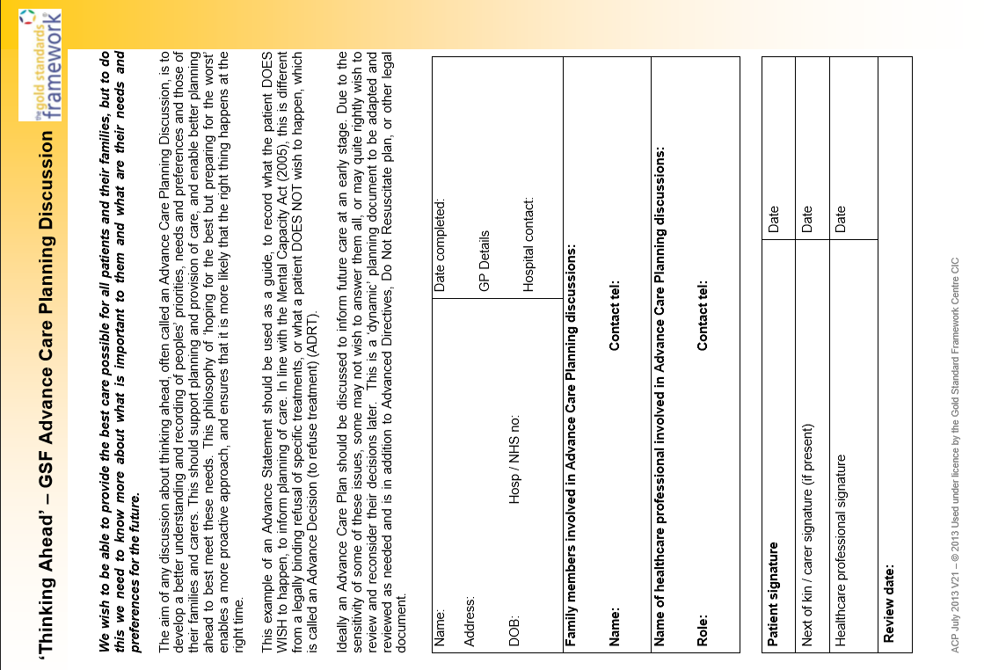

Nightingale Hammerson May 2016 A3a - Page 1 of 2

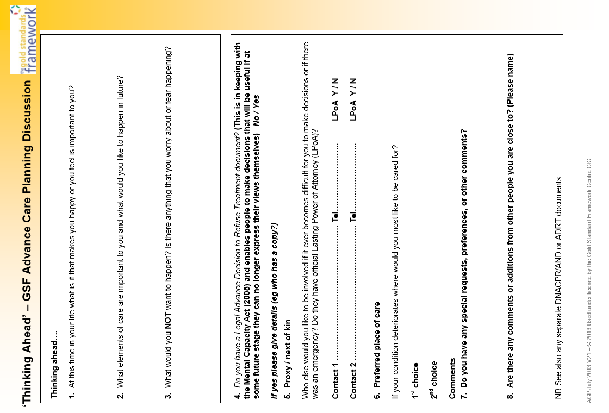

Nightingale Hammerson May 2016 A3a - Page 2 of 2